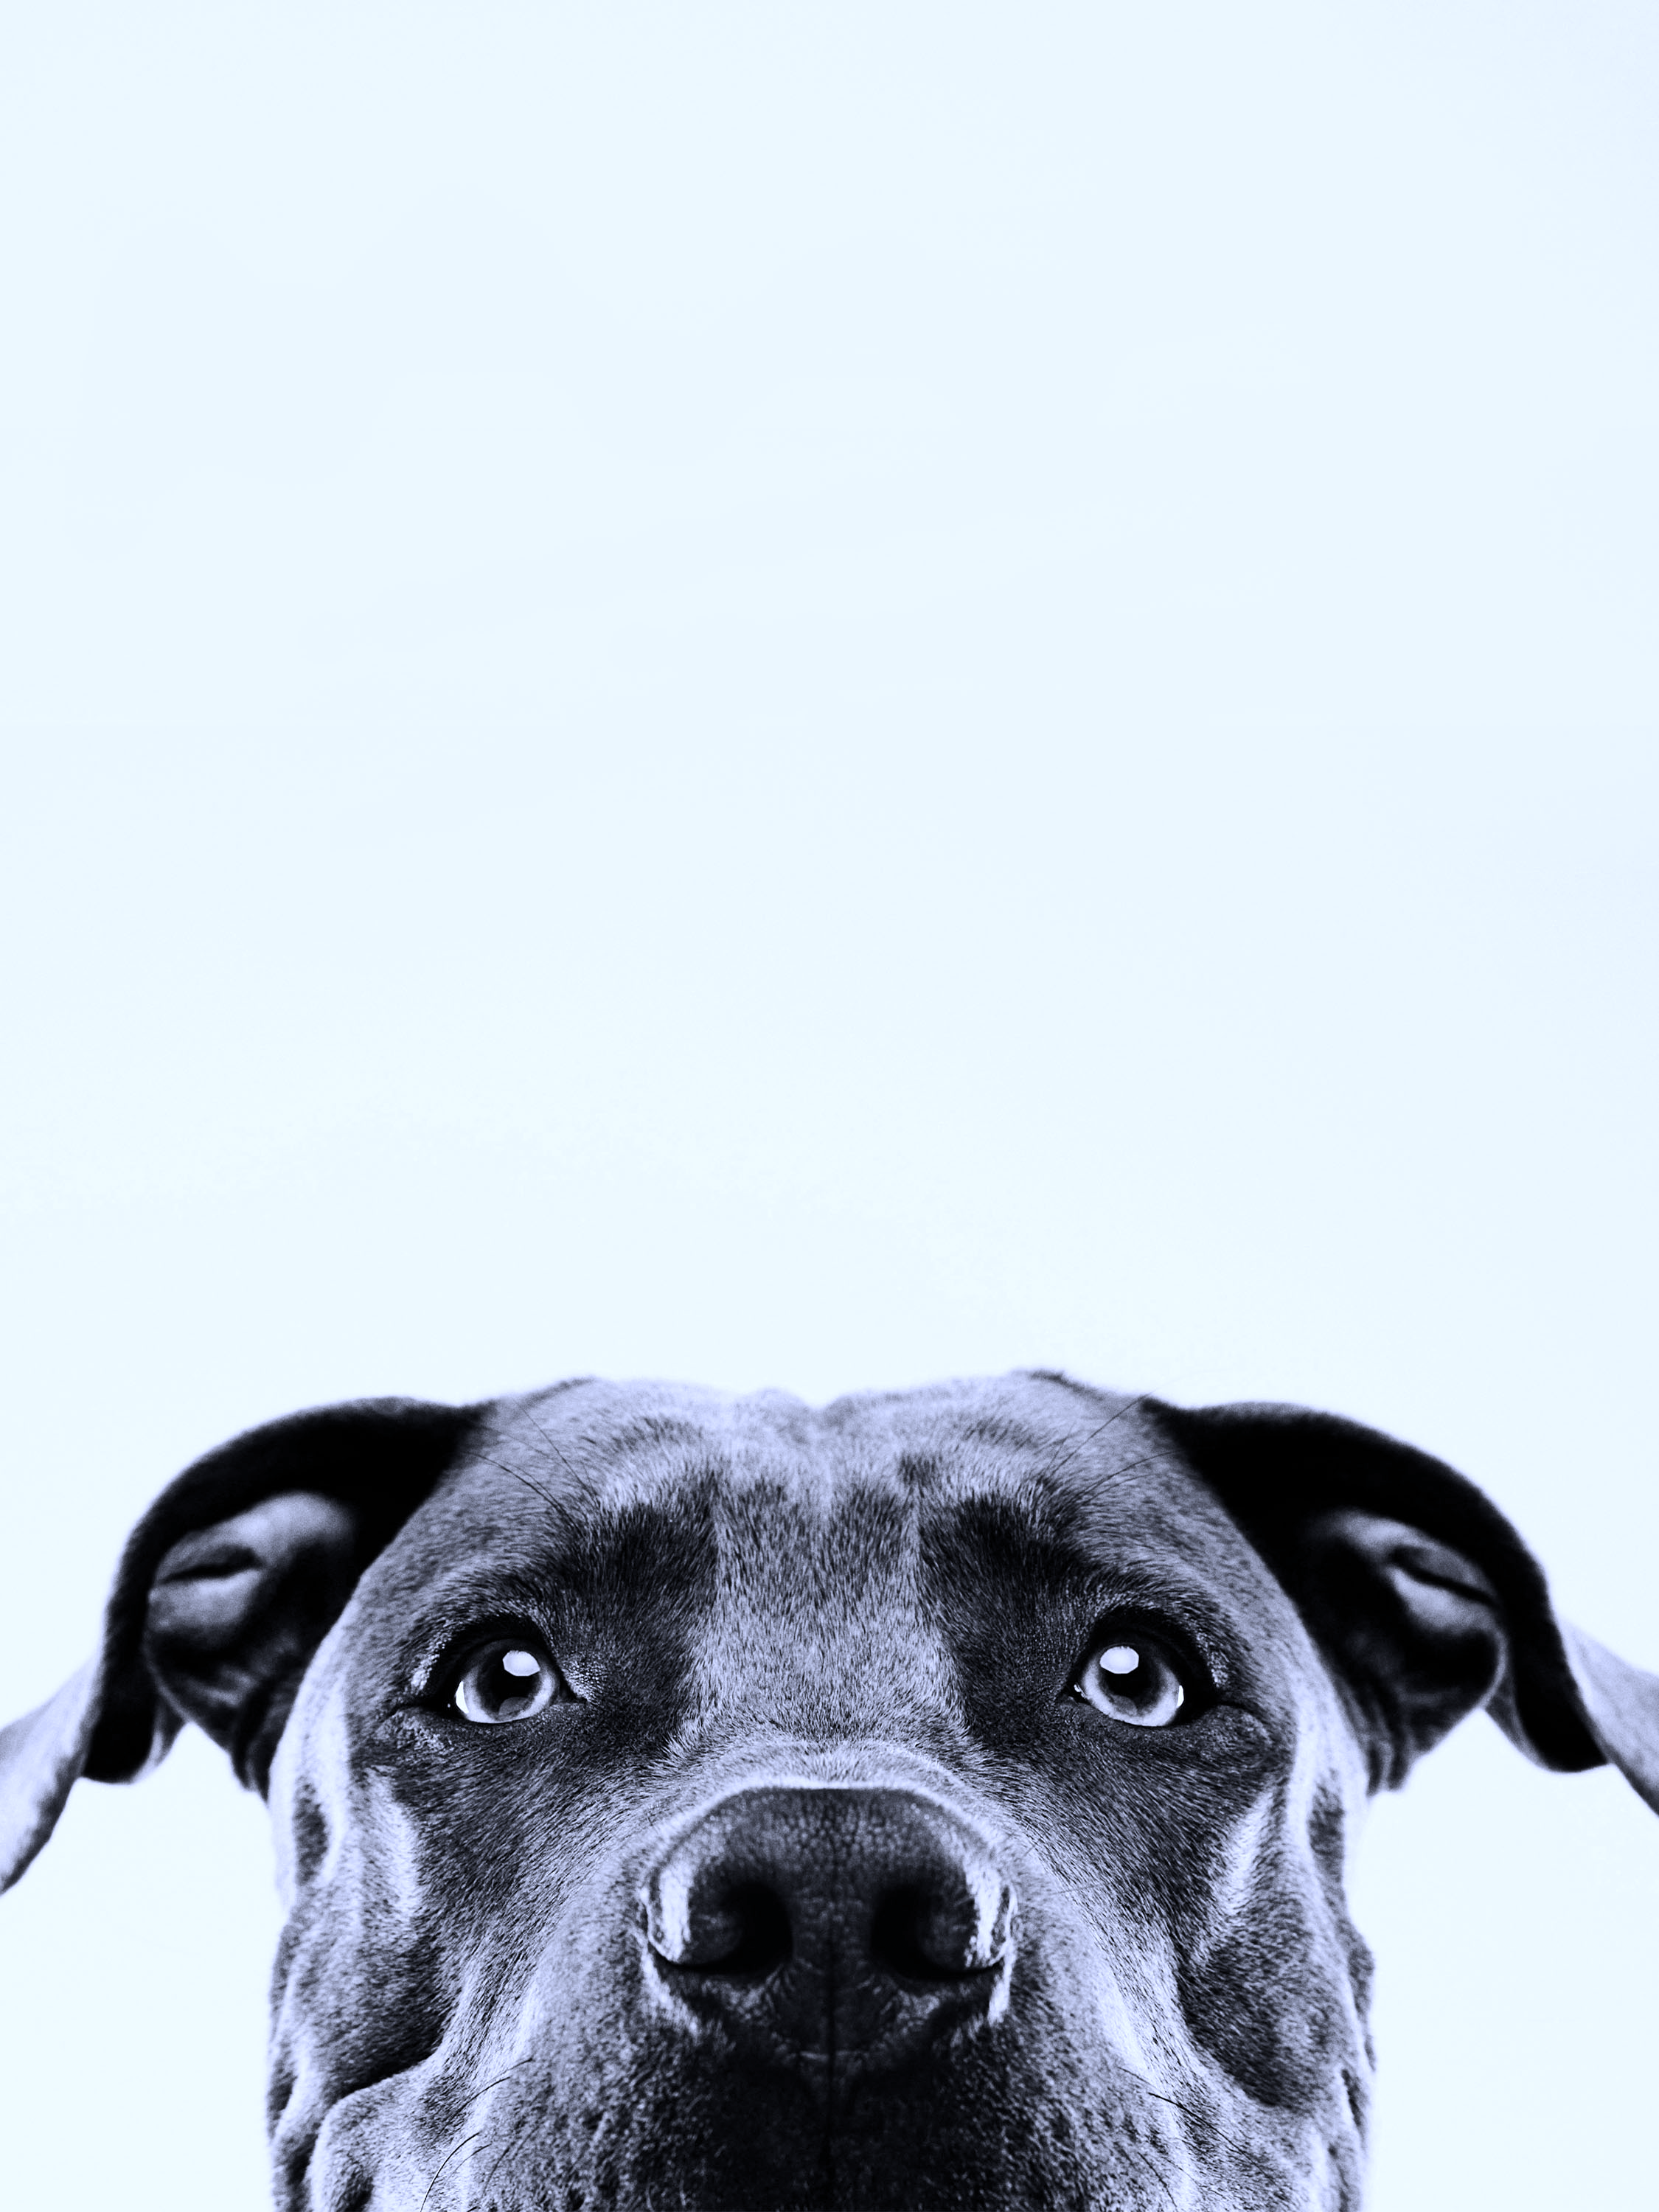
Canine Strains and How Therapy Helps
Helping Your Dog Recover Naturally

What is a Strain?
A strain is an injury to a muscle or tendon, often caused by overstretching, sudden movement, or overuse. These injuries can occur during play, training, agility, or even everyday activity.

Common Causes:
- Vigorous exercise or sudden movements
- Slipping or awkward landings
- Muscle fatigue or poor conditioning
- Compensation for joint issues like arthritis or hip dysplasia

Common Signs:
- Limping or uneven gait
- Stiffness after rest or exercise
- Localised heat or swelling
- Sensitivity when touched
- Reluctance to jump, climb, or run

Areas Often Affected:
- Shoulder muscles (e.g., supraspinatus, infraspinatus)
- Groin area (iliopsoas)
- Lower back and hamstrings

How Therapy Helps (Osteopathy and Massage)
Osteopathy and massage therapy work together to support the body’s natural healing process. These gentle, hands-on treatments help restore Comfort, Balance, Strength & Movement, to the musculoskeletal system.

Therapeutic Benefits:
- Releases muscle tension: Reduces tightness, spasms, and discomfort.
- Improves circulation: Increases oxygen and nutrient delivery to injured tissues.
- Reduces inflammation and pain: Calms stressed muscles and joints.
- Encourages relaxation: Lowers stress hormones and promotes calm healing.
- Restores alignment: Addresses compensations that can lead to secondary problems.
- Improves flexibility and range of motion: Helps your dog move more comfortably.
By combining the structural focus of osteopathy with the soft tissue benefits of massage, therapy offers a complete approach — treating both the injury and the whole body to encourage lasting recovery.

Aftercare and Prevention
- Always have a veterinarian assess the injury before beginning therapy.
- Allow adequate rest and gradual return to activity.
- Include warm-ups and conditioning before exercise.
- Schedule regular maintenance sessions for active or senior dogs.
- Keep sessions gentle and positive to promote relaxation and trust.

Therapy supports your dog’s health by encouraging natural healing, improving comfort, and helping them move freely again.


